## **PAC-Poly-Hi--Atooi-Kauai-Taking on Provisions-Webber-Cook-1784**

## An Inland View in Atooi, One of the Sandwich Islands

36 cm x 22 cm copperplate engraving, 39 cm x 25 cm sheet size, modern hand colour, Alexander Hogg, London, 1784-1786

We are pleased to offer this scarce and historically important original fine art engraving after an [original drawing](http://www.captcook-ne.co.uk/ccne/exhibits/19358/index.htm) by the [*HMS Resolution*](http://en.wikipedia.org/wiki/HMS_Resolution_(1771))ship's artist [John Webber](http://en.wikipedia.org/wiki/John_Webber) (1751-1793) on James Cook's third and final voyage from the *New, Authentic, Entertaining, Instructive, Full and Complete Historical Account of Captain Cook's First, Second, Third and Last Voyages*[1](http://vi.vipr.ebaydesc.com/ws/eBayISAPI.dll?ViewItemDescV4&item=261663570638&t=1416085660000&tid=10&category=360&seller=regiomontanus&excSoj=1&excTrk=1&lsite=0&ittenable=false&domain=ebay.com&descgauge=1" \l "1) published serially between 1784 and 1786.  The historically important drawing was sketched after Cook's arrival at Kauai in 1778 near Waimea Bay where the crew of the *Resolution* and *Discovery* were warmly received and successfully traded and replenished water and food.  Cook described the scene in his journal:

"We no sooner landed than a trade was set on foot for hogs and potatoes, which the people gave us in exchange for nails and pieces of iron formed into something like chisels. We met with no obstructions in watering, on the contrary the Natives assisted our people to roll the casks to and from the pond.  At sun set I brought every body on board, having got during the day Nine tons of water….about sixty or eighty Pigs, a few Fowls, a quantity of potatoes and a few plantains and Tara roots."2

Webber was recommended to the Admiralty for appointment as artist for the voyage by the Swedish botanist [Daniel Carlsson Solander](http://en.wikipedia.org/wiki/Daniel_Solander) (1733-1782) who had accompanied Cook on his first voyage.  Just 24 years old when he joined the *Resolution* at Plymouth one week prior to departure,  Webber's skill in both portraiture and landscape resulted in a visual record of Cook's third voyage that is unsurpassed in the annals of 18th century exploration.  In their monumental four-volume work *The Art of Captain Cook's Voyages*3 authors Rüdiger Joppien and Bernard Smith observe that Webber's relationship with Cook was unique, noting that:

"Cook clearly had it in mind on this voyage to publish his own account on his return and it is also clear that he regarded Webber as his visual collaborator in that undertaking from the beginning... Webber is frequently on the spot with Cook and often depicts incidents, scenes or portraits of individuals mentioned by Cook in his journal... In Webber's drawings with their emphasis upon description, the recording of notable events, and linear accuracy, we may perhaps see something of Cook's guiding hand..."

An iconic image that is a true classic of Pacific illustration, this strong imprint is enhanced by finely executed hand colour work in accordance with the palette of Webber's later water colours of the image.  One of the more sought-after of 18th century engravings of Webber's illustrations, this handsome example will make an elegant presentation if matted and framed and an important addition to any collection related to Hawaii or the voyages of James Cook.

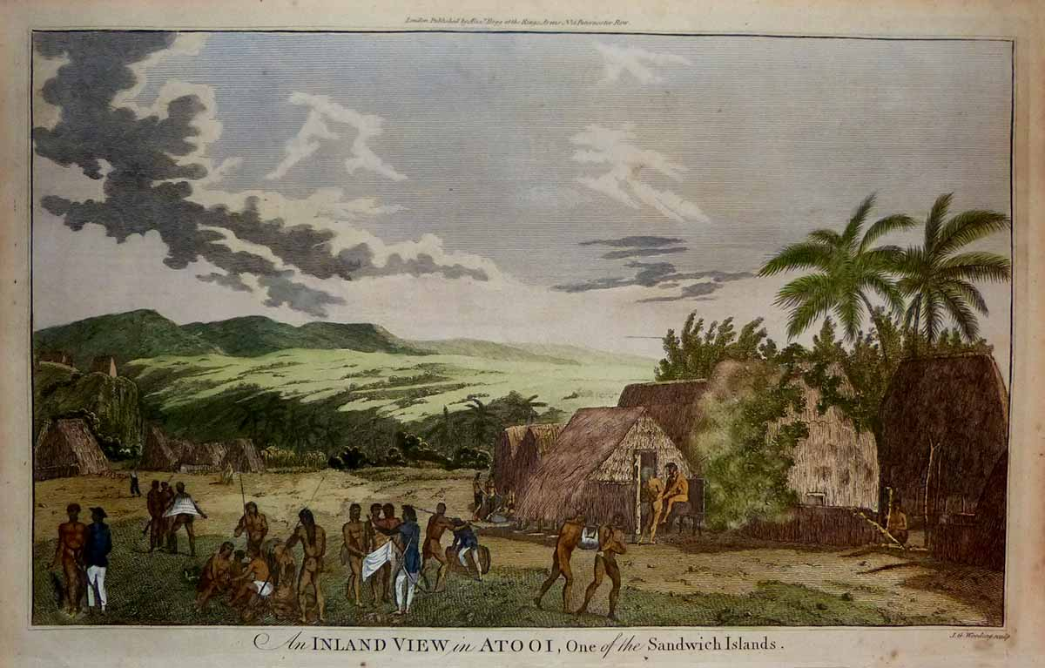

Prior to seeking provisions here at Kauai Cook issued his famous orders banning firearms on shore and protecting the natives against what he called "The Venereal"  
  
"And whereas it has frequently happened that by Officers and others travelling in the Country with Fire-Arms and other Weapons, in order to obtain which, the Natives have committed thefts and outrages, they otherwise would not have attempted; it is therefore Ordered that no Officer or other person (not sent on duty) shall carry with him out of the Ships, or into the Country, any fire Arms whatever, and great care is to be taken to keep the Natives ignorant of the method of charging such as we may be under a necessity to make use of..."    
  
In order to prevent as much as possible the communicating this fatal disease to a set of innocent people', no woman was to be admitted on any pretence into either ship without the captain's permission; any man party to such an entry would be punished; any man having the disease, or under suspicion of having it, who lay with a woman would be severely punished; no suspected person would be allowed on shore on any pretence whatever"2

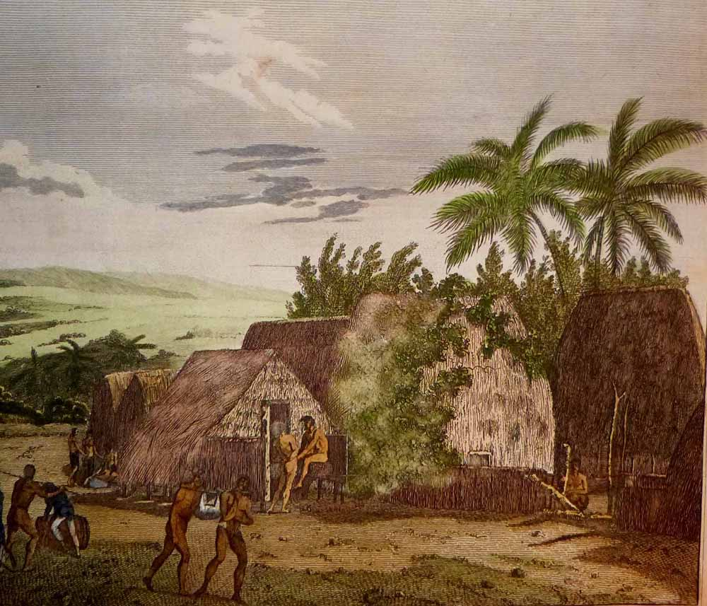

Note crew member rolling barrel towards pond for water collection.  To get a sense of print detail consider that the officer with the sword speaking with a group of three Kauai natives stands just 4 cm tall actual size:

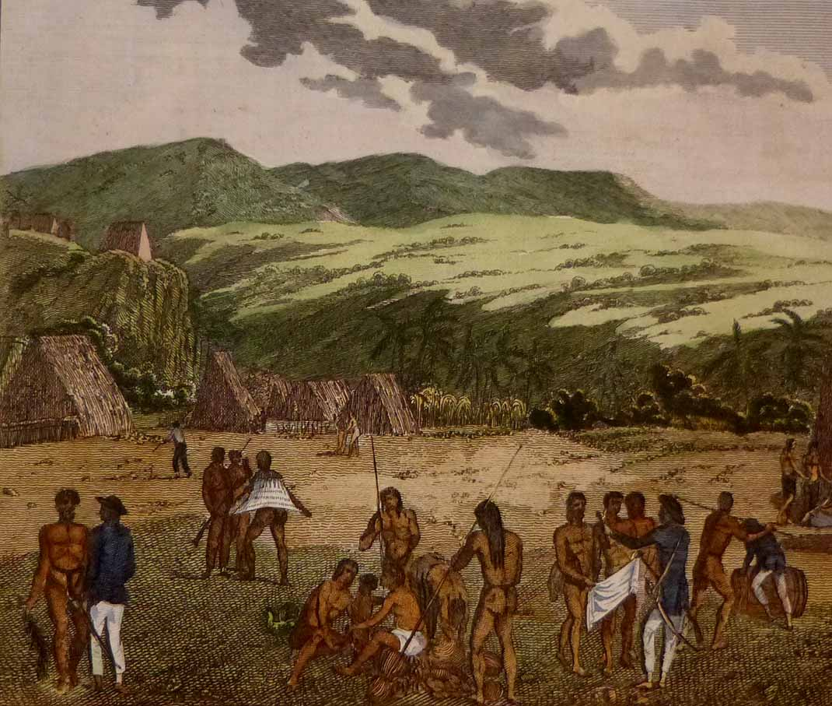

Condition - Please note carefully:  The print is in very good condition as can be ascertained from photos, image area essentially pristine, no text on verso, no folds, strong impresssion on fine quality laid paper, excellent hand colour work, trivial scattered soiling to margin extremities, somewhat close and slightly uneven trim to margins.  [Inquiries](mailto:jfazli@ix.netcom.com) welcome and we encourage you to visit our other [listings](http://cgi6.ebay.com/aw-cgi/eBayISAPI.dll?ViewListedItems&userid=regiomontanus&sort=3&since=-1) on eBay.  
  
NOTES:  
  
1. The editor of the *New, Authentic, Entertaining, Instructive, Full and Complete Historical Account of Captain Cook's First, Second, Third and Last Voyages* was named as one "George William Anderson",  almost certainly a pseudonym for the publisher Alexander Hogg.  In a recent exhibition of these historically important engravings made for this publication the Lowe Art Museum in Miami noted that the pseudonym was "a device Hogg employed in a number of his publications" intended to convey an "aura of authoritative knowledge" regarding his editing of the official publications of the voyages.  Hogg shrewdly elected to publish the work (which eventually included accounts of other circumnavigations) in a relatively affordable serial format from 1784-1786 to reach a broad audience, noting in his marketing copy that this was "due to the many thousands of Persons who would wish to peruse the Discoveries... and view the astonishing fine Copper-Plates, who have hitherto been excluded from gratifying their eager curiosity.  These installments would allow every Person, whatever may be his Circumstances, to read about the voyages of which such vast Sums of the Public Money have been expended."  
  
2.  Cook, James. *A Voyage Towards the South Pole and Round the World: Performed in His Majesty’s Ships the Resolution and Adventure, in the Years 1772, 1773, 1774 and 1775*. 1st ed. 2 vols. London, 1777  
   
3.  New Haven; Four Volumes, Published for the Paul Mellon Centre for Studies in British Art by Yale University Press 1985-1988.  